ORAL HEALTH

Definition

Oral health is the state of the mouth, teeth and orofacial structures that enables individuals to perform essential functions, such as eating, breathing and speaking, and encompasses psychosocial dimensions, such as self-confidence, well-being and the ability to socialize and work without pain, discomfort and embarrassment. Oral health is integral to general health and supports individuals in participating in society and achieving their potential.

Oral diseases encompass a range of diseases and conditions, including:
- dental caries (tooth decay);
- periodontal (gum) diseases;
- tooth loss;
- oral cancer;
- oro-dental trauma;
- noma; and
- congenital malformations, such as cleft lip and palate.

Occurrence of oral diseases

Oral diseases are among the most common noncommunicable diseases (NCDs) worldwide. According to the World Health Organization (WHO), they affect nearly 3.7 billion people globally. Untreated dental caries (tooth decay) in permanent teeth is the most common oral disease and is also the most common health condition assessed by the Global Burden of Disease Study. Taken together, oral diseases have a higher global prevalence than any other noncommunicable disease (NCD). The number of people affected by oral diseases substantially exceeds the number affected by cardiovascular diseases, diabetes mellitus, chronic respiratory diseases, mental disorders or cancers (Figure 1).

Figure 1. Comparison of the number of cases of selected noncommunicable diseases worldwide (excluding lip and oral cavity cancer).
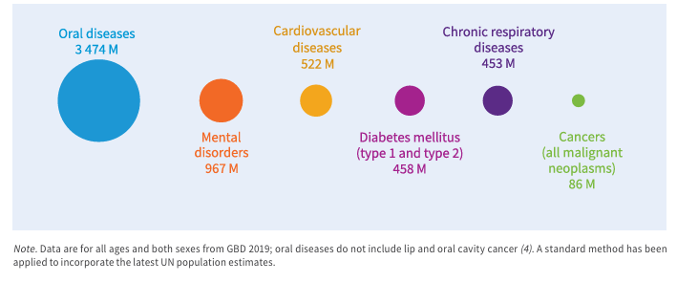
Untreated dental caries affects approximately 2.5 billion people worldwide. Other major oral diseases and conditions include periodontal diseases, tooth loss and oral cancers. Severe periodontal disease affects approximately 1 billion people worldwide, while complete tooth loss affects about 350 million people. In addition, approximately 380,000 new cases of oral cancer are diagnosed each year. Oral diseases share common risk factors with other major noncommunicable diseases (NCDs) and impose a substantial health, social and economic burden on individuals, families and health systems. The largest absolute number of cases occurs in lower-middle- and upper-middle-income countries, which together account for approximately three-quarters of people affected by oral diseases worldwide. However, the overall prevalence of oral diseases is relatively similar across country income groups and is approximately 45% (Figure 2). Oral diseases therefore represent a global public health challenge across countries at all income levels. Socioeconomic inequalities remain particularly important, with vulnerable and disadvantaged population groups carrying a disproportionately high burden of oral diseases. These inequalities are reflected in differences in the prevalence and burden of dental caries, periodontal diseases and tooth loss both between countries and between socioeconomic groups within populations.
Figure 2. Prevalence of major oral diseases by country income group (excluding lip and oral cavity cancer).
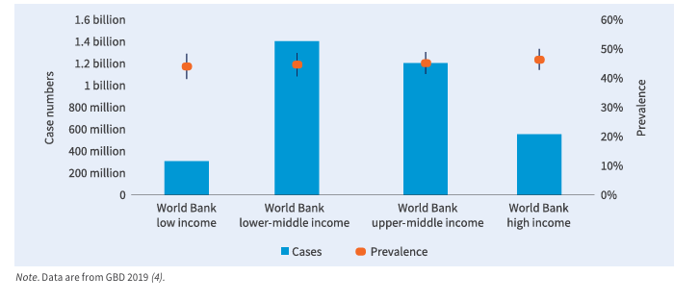
The number of people affected by oral diseases has shown an increasing trend across all country income groups (Figure 3). The total number of affected individuals increased from approximately 2.3 billion to more than 3.4 billion. The most pronounced increase was observed in lower-middle- and upper-middle-income countries. This trend reflects global population growth, urbanization, changes in lifestyle, and persistent shortcomings in the prevention and control of oral diseases.
Figure 3. Trends in the number of cases of major oral diseases, 1990–2019 (excluding cancers of the lip and oral cavity).
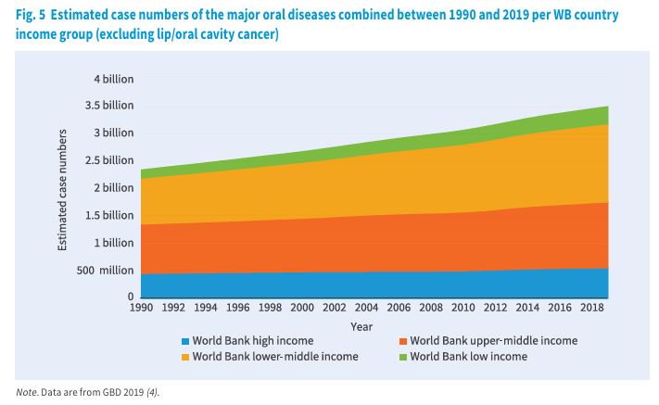
Although oral diseases are among the most prevalent health conditions worldwide in terms of the number of people affected, their overall disease burden is lower than that of other major noncommunicable diseases (Figure 4). Cardiovascular diseases account for the highest burden, followed by cancers, mental disorders, chronic respiratory diseases and diabetes mellitus. Oral diseases account for approximately 23 million disability-adjusted life years (DALYs) of the global disease burden.

Figure 4. Comparison of the global burden of selected noncommunicable diseases expressed in disability-adjusted life years (DALYs), based on GBD 2019 estimates.
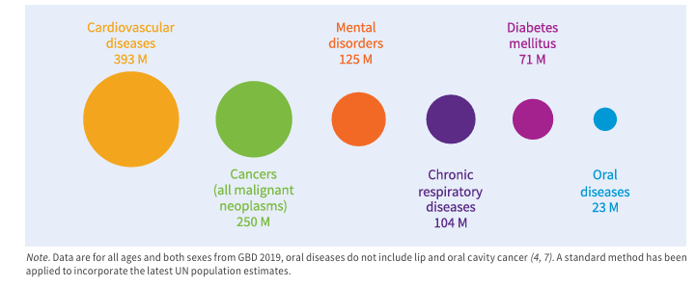

Dental caries

Evidence of dental caries has been found in skeletal remains dating back to the Stone Age. The prevalence of dental caries increased gradually from ancient times through the Middle Ages to the modern era, with a marked increase occurring particularly during the last 200 years. Dental caries has progressively affected younger age groups and currently also occurs in the primary dentition of young children. There are considerable global differences in the occurrence of dental caries (Figure 5). The decline in dental caries observed in developed countries has been associated primarily with the widespread use of fluoride toothpaste, improved access to preventive and curative dental care, higher levels of health literacy, and the implementation of population-based preventive programmes. Regular oral health monitoring and early intervention have also played an important role. In contrast, in many developing countries, the increasing burden of dental caries has been associated with urbanization, increased availability and consumption of foods and beverages high in sugar, inadequate exposure to fluoride, and limited access to preventive and curative dental care. The prevalence of oral diseases remains closely associated with socioeconomic conditions and inequalities in access to health care, particularly among socially disadvantaged and marginalized population groups.

Figure 5. Comparison of trends in dental caries among 12-year-old children in developing and developed countries, 1980–2002.
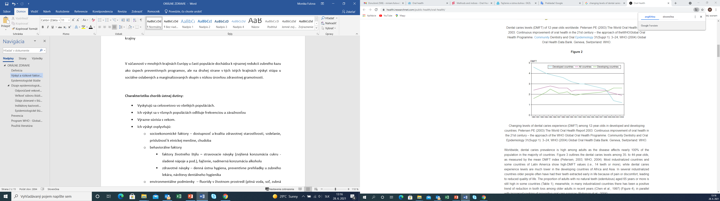
Source: Petersen, 2003

Epidemiological characteristics and risk factors of oral diseases

From an epidemiological perspective, oral diseases are characterized by the following:
- They occur worldwide across all populations.
- Their frequency and severity vary between populations.
- Their occurrence is strongly associated with age.
- Their occurrence is influenced by a complex interaction of biological, socioeconomic, behavioral and environmental factors.
Many of these factors are also associated with other noncommunicable diseases and overall quality of life, providing the basis for the concept of common risk factors (Figure 6). This concept is known as the Common Risk Factor Approach (CRFA) and forms the basis of modern preventive strategies in dentistry and public health. The risk factors for oral diseases are largely modifiable risk factors (Figure 7). For example, behavioural risk factors can be modified by adopting a healthy lifestyle and improving health-related behaviours, thereby reducing the risk of oral diseases and promoting overall health. There is a well-established relationship between oral health and general health. Diabetes mellitus is associated with the development and progression of periodontitis, and there is also a causal relationship between high sugar consumption and diabetes, obesity and dental caries.

Figure 6. The risk factor approach in promotion of oral health
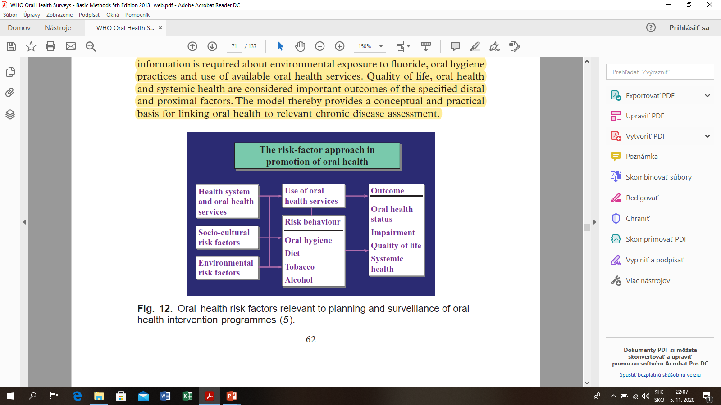Source: Petersen, 2002

Figure 7. Risk factors of oral diseases.
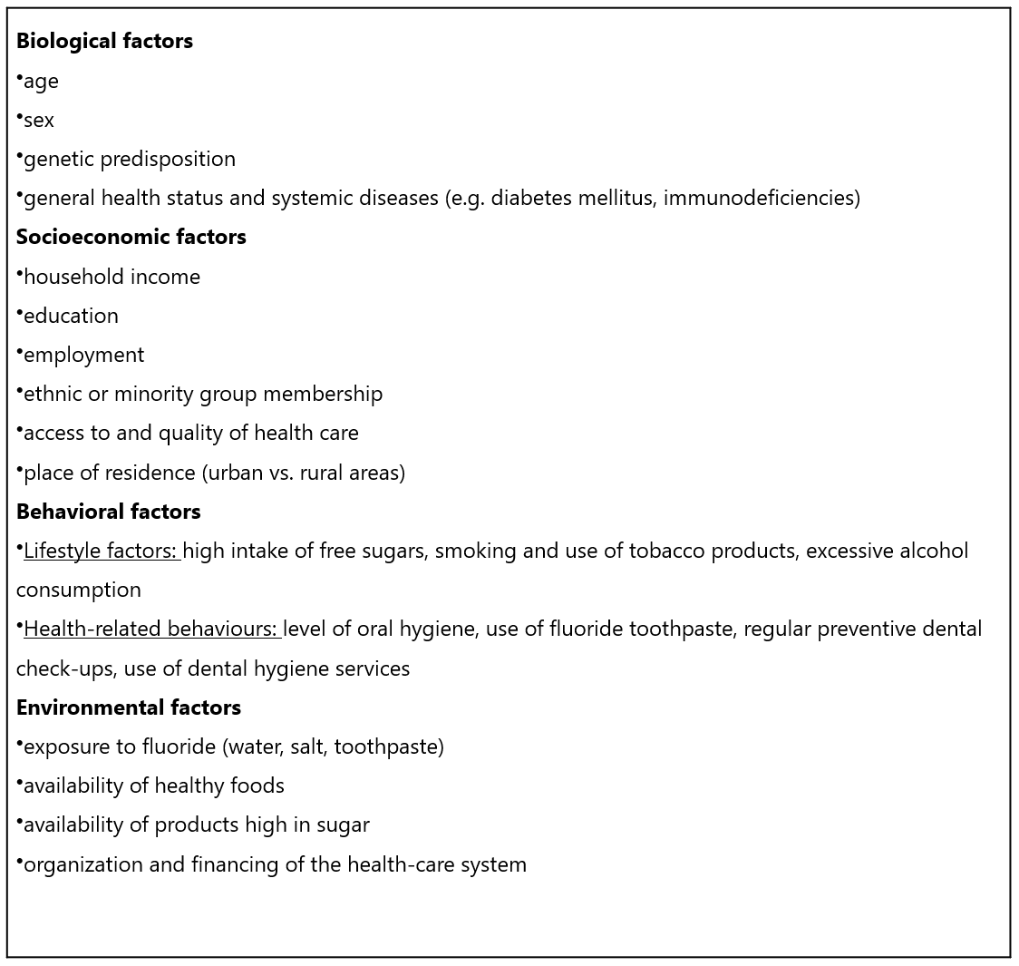

Complex Interaction of Oral Health Determinants
Common risk factors are driven by wider socioeconomic, political and environmental determinants (Figure 8). Macroeconomic and social policies, trade relations, urbanization, globalization, and the overall level of societal development shape an individual’s social position, education, income, working conditions, and access to health care. At the individual level, health is influenced by social class, level of education, sex, ethnicity, material circumstances, psychosocial factors, health-related behaviours, and environmental conditions. These determinants subsequently influence dietary habits, alcohol consumption, tobacco use, physical activity, and hygiene practices. Their combined effects contribute to biological processes such as inflammation, infection, and changes in the immune response, which are involved in the development of dental caries, periodontal diseases, tooth loss, and other oral diseases. Commercial determinants of health also play an important role. These include marketing strategies used by manufacturers of tobacco products, alcoholic beverages, and foods high in sugar, as well as media campaigns and other mechanisms that shape consumer behaviour. WHO emphasizes that the increasing availability and intensive promotion of such products contribute to the persistently high global burden of oral diseases. Effective prevention therefore needs to address not only individual behaviours and risk factors, but also the broader social, commercial, and policy environments in which these behaviours occur.

Figure 8: Social Determinants of oral health
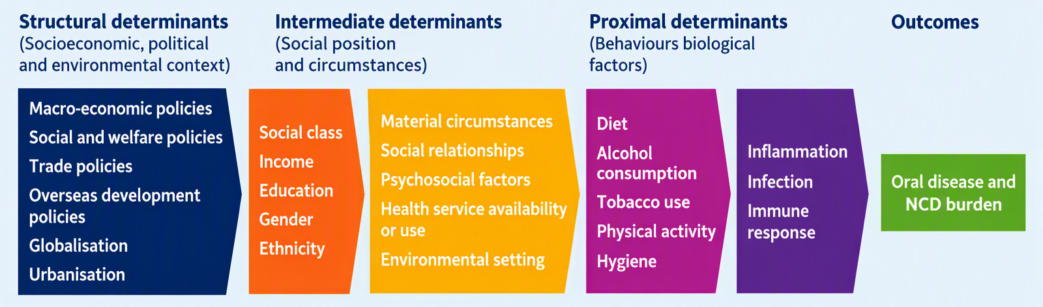
Source: WHO, Global oral health status report, 2022

Oral Health Surveys

Oral health surveillance is the continuous collection, analysis, and interpretation of data on the oral health status of a population. Active surveillance is conducted through repeated epidemiological surveys, which are recommended at intervals of approximately 5–6 years. These surveys provide information on:
- the current prevalence of oral diseases in the population,
- trends in the occurrence of oral diseases over time,
- the effectiveness of preventive programmes,
- the planning of future dental care and preventive measures.
The aim of epidemiological surveys is to contribute to the control of oral diseases and to reduce their impact on quality of life. A standardized methodology for epidemiological oral health surveys has been available since 1971, enabling comparisons of oral health status between populations and countries. The evaluation of numerous epidemiological studies conducted in different countries has contributed to the identification of important risk factors and determinants affecting oral health. Epidemiological surveys are particularly important for primary prevention, as they help to identify population groups at increased risk. The findings can be used to develop appropriate primary prevention strategies, target preventive interventions, and plan the education and training of oral health professionals.

Design of an Oral Health Epidemiological Survey

The selection of the study population should include population groups that are particularly important for identifying differences in oral health status, especially with regard to age and socioeconomic factors. The following age groups are recommended for the assessment of oral health status in the population:
- 5 years: assessment of the primary dentition at approximately the age when children begin school.
- 12 years: the key age group used for international comparisons. By this age, almost all permanent teeth, except the third molars, have erupted. In addition, study participants in this age group can be relatively easily recruited through the school system.
- 15 years: assessment of oral health and permanent dentition during adolescence.
- 35–44 years: the standard age group for oral health surveillance in adults, providing information on the cumulative effects of oral diseases, dental care, and preventive measures during adulthood.
- 65–74 years: this age group enables oral health to be assessed from a life-course perspective and provides information on the cumulative effects of oral health care and prevention in the population.

Sample Size in Oral Health Surveys

An oral health survey usually includes 10–15 sampling sites representing both urban and rural areas of a country. At each site, approximately 25–50 individuals from each selected age group are included, with an approximately equal representation of males and females. For example, if 300 individuals are included in each age group, a survey covering five age groups would have a total sample size of approximately 1,500 individuals (5 age groups × 300 individuals) (Table 1).
Table 1. Minimum sample size for an oral health survey in a population for one age group
 | Number of sites | Number of persons*
Urban area
Capital city | 4 sites | 4 x 25 = 100
2 large towns | 2 sites in each town | 2 x 2 x 25 = 100
Rural area
4 villages in different regions | 1 site in each village | 1 x 4 x 25 = 100
Total for one age group | 12 sites | 12 x 25 = 300
*minimal number of subjects in one sampling site = 25

Data Collected in an Oral Health Survey

Data collection is carried out in a standardized manner to ensure consistent interpretation of the results. Data are collected by a trained team of professionals with clearly defined roles, typically including an epidemiologist, dentist, administrative staff member, data manager, and statistician.
An oral health survey also includes an assessment of the sources of fluoride exposure in the participants’ environment, such as drinking water, salt, food, toothpaste, and other sources, as these may influence oral health status. At each survey site, a sample of drinking water should be tested for fluoride concentration, or information on fluoride levels should be obtained from available environmental data.
In addition, data collection consists of two main components:
1. Clinical Examination of Oral Health Status
The clinical examination assesses the status of the dentition and periodontal tissues, gingival recession, dental fluorosis, dental erosion, traumatic dental injuries, oral mucosal lesions, and the presence and condition of dental prostheses. The need for urgent intervention or further dental treatment is also evaluated. The scope of the examination may vary depending on the age group and whether children or adults are being examined.
2. Oral Health and Risk Factor Questionnaire
A standardized anonymous questionnaire, usually administered as an interview, provides information on toothbrushing practices; the frequency of and reasons for dental visits and visits to a dental hygienist; lifestyle-related risk factors, including dietary habits, tobacco use, and excessive alcohol consumption; and the participant’s experience of oral diseases and conditions, such as oral pain or discomfort and the use of dental prostheses. Information on the presence of other chronic diseases and conditions, such as diabetes or HIV infection, may also be collected.

Indicators of Dental Caries and Periodontal Diseases for Oral Health Assessment

Epidemiological indices can be calculated on the basis of data collected during oral health surveys or based on data form routine reporting. These indices are used to quantify the occurrence of a condition of interest, such as dental caries or periodontal disease, and enable comparisons between different population groups. They usually express the occurrence or burden of the condition using relative or standardized measures.
Prevalence of dental caries is a simple method for assessing the occurrence of dental caries in a population. The population can be divided into two groups: 1. individuals without dental caries and 2. individuals affected by dental caries.
- If more than 50% of the population is caries-free, the prevalence of dental caries is considered low.
- If less than 20% of the population is caries-free, the prevalence of dental caries is considered high.

DMFT index (Decayed, Missing, Filled Teeth) is used in the permanent dentition to assess the cumulative experience of dental caries in an individual or population. It is calculated as the sum of decayed (D), missing due to caries (M), and filled (F) permanent teeth. For example, a DMFT score of 4–3–9 = 16 indicates 4 decayed teeth, 3 teeth missing due to caries, and 9 filled teeth. Assuming a complete permanent dentition of 28 teeth excluding third molars, 12 teeth would be sound. At the population level, the mean DMFT index reflects the population's cumulative caries experience and can be classified from low to high according to established reference values (Tables 2 and 3)
Table 2. Mean DMFT index values among 12-year-old children
Classification | mean DMFT
Very low | < 1,2
Low | 1,2 – 2,6
Moderate | 2,7 – 4,4
High | 4,5 – 6,5
Very high | > 6,5

Table 3. Mean DMFT index values among adults aged 35–44 years
Classification | mean DMFT
Very low | < 5,0
Low | 5,0 – 8,9
Moderate | 9,0 – 13,9
high | > 13,9

The Significant Caries Index (SiC Index) represents the mean DMFT value in the one-third of the population with the highest DMFT scores (Figure 9). The SiC Index is calculated as follows:

- The study population is ranked according to individual DMFT values.
- The one-third of the population with the highest DMFT values is selected.
- The mean DMFT value is calculated for this subgroup. This value represents the SiC Index.

Twelve-year-old children with a high level of caries experience are likely to have greater dental treatment needs later in life. The SiC Index helps to identify the segment of the population with the highest caries burden and enables preventive interventions to be targeted specifically at this high-risk group.

Figure 9. DMFT and SiC indices among 12-year-old children.
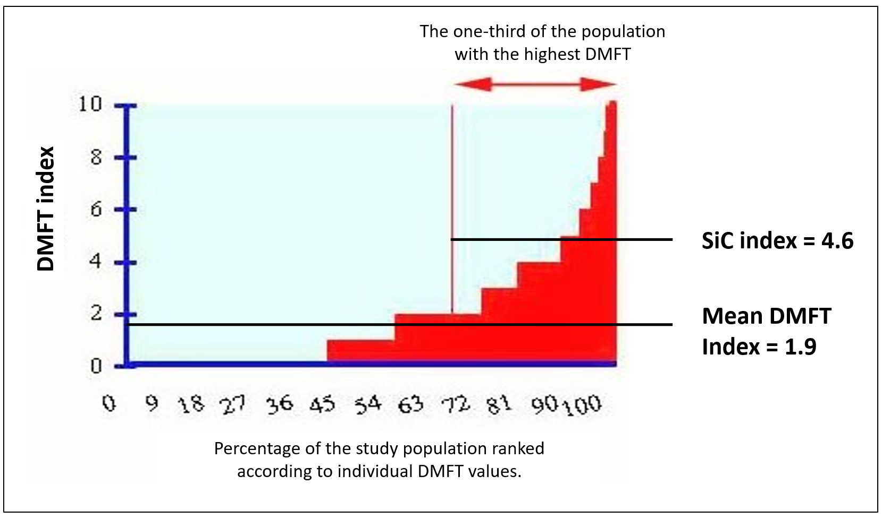

The Community Periodontal Index (CPI) is used to assess periodontal status based on four clinical signs:
- Gingival bleeding
- Presence of dental calculus
- Presence of shallow periodontal pockets
- Presence of deep periodontal pockets
For the purposes of the examination, the dental arches are divided into sextants, and selected index teeth are examined in each sextant. In adults, the standard index teeth include: 17/16, 11, 26/27 and 47/46, 31, 36/37. The examination is performed using a WHO periodontal probe, which has a 0.5 mm ball-shaped tip designed to minimize tissue trauma during probing.

The CPI scoring system is as follows:
0 – healthy periodontium
1 – gingival bleeding
2 – dental calculus detected
3 – shallow periodontal pockets
4 – deep periodontal pockets
The results are evaluated by calculating the number and percentage of individuals, sextants, or teeth assigned to each CPI score from 0 to 4.

Oral Health Data Sources
Monitoring oral health at the global, regional, and national levels relies on data collected through national and international databases and health information systems.

National Databases
National health information systems and databases are important sources of oral health data. Depending on the country, data may be collected by ministries of health, national public health institutes, statistical offices, health insurance systems, professional organizations, or other health authorities. National data sources may include population-based oral health surveys, routine health statistics, dental service utilization and treatment data, disease registries, workforce statistics, and information on preventive programmes. These data are used to monitor oral health status and inequalities within the population, identify priority groups, assess access to and utilization of oral health services, plan workforce and resources, and evaluate national oral health policies and prevention programmes. WHO emphasizes the integration of oral health indicators into national health information and surveillance systems and their use for monitoring progress towards national and global oral health targets. National data also contribute to the development of WHO country oral health profiles and facilitate comparisons between countries.

International Databases
These sources provide information on the prevalence and incidence of oral diseases, their risk factors, access to health care, and the burden of oral diseases across countries and regions worldwide. The collected data are used to assess population oral health status, develop health policies, plan preventive programmes, and enable international comparisons of oral health indicators.
One of the most important international sources of oral health data is the World Health Organization (WHO). Through the WHO Oral Health Data Portal, WHO provides epidemiological data on major oral diseases and conditions, including dental caries, periodontal diseases, tooth loss, and oral cancer. The database enables comparisons between countries and WHO regions and represents an important source of information for monitoring oral health at the international level.
https://www.who.int/data/gho/data/themes/oral-health-data-portal
Another important source of epidemiological data is the Global Burden of Disease (GBD) Study, coordinated by the Institute for Health Metrics and Evaluation (IHME). The project provides comprehensive information on the prevalence, incidence, mortality, and burden of numerous diseases and conditions, including oral diseases. Disease burden can be expressed using measures such as disability-adjusted life years (DALYs). GBD data form the basis of many global health analyses and were also used in the preparation of the WHO Global Oral Health Status Report 2022.
https://www.healthdata.org/research-analysis/gbd
An important reference document is the Global Oral Health Status Report: Towards Universal Health Coverage for Oral Health by 2030, which provided the first comprehensive global overview of oral health status. The report highlighted that oral diseases are among the most prevalent noncommunicable diseases worldwide and emphasized substantial inequalities in oral health between countries and among different socioeconomic groups.
https://www.who.int/news-room/events/detail/2022/11/18/default-calendar/launch-of-the-who-global-oral-health-status-report

Prevention

Population-based epidemiological studies have demonstrated that changes in disease risk factors are associated with changes in disease occurrence. By modifying relevant risk factors, the development of oral diseases can be partially prevented, as in the case of oral cancer, or largely prevented, as in the case of dental caries. Successful prevention depends both on individual health-related behaviour and on the attitudes and values of society as a whole. Oral hygiene should be regarded as an integral part of personal hygiene, general health, and a healthy lifestyle.

Evidence-based primary prevention is a cornerstone of oral health (Figure 10). Effective prevention requires a systematic approach combining several measures, including appropriate toothbrushing techniques, regular use of fluoride toothpaste, fluoridation of drinking water or salt where appropriate, modification of dietary habits with particular emphasis on reducing sugar intake, and regular preventive dental examinations. For adults, sugar consumption should ideally remain below 18 kg per person per year, equivalent to approximately 50–60 g per person per day. Health education and the development of positive attitudes towards personal health and individual responsibility for oral health also play an important role.

Figure 10. Basic principles of primary prevention in oral health
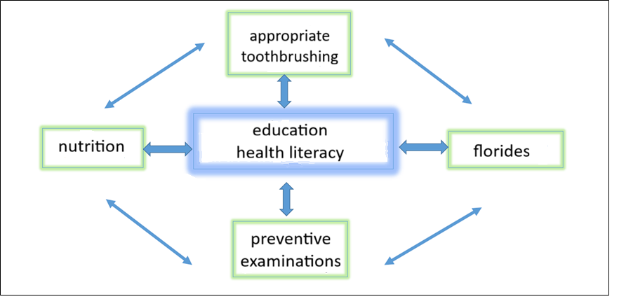

WHO Global Oral Health Programme

The WHO Oral Health Programme is a major international initiative aimed at promoting oral health, based on the recognition that oral health is an integral part of general health, well-being and quality of life. The programme promotes evidence-based approaches to the prevention and management of oral diseases and conditions and builds on current knowledge of oral health risk factors. One indicator of successful oral disease prevention is a reduction in the number of decayed teeth among children. A major milestone was the adoption of the Resolution on Oral Health by the World Health Assembly in 2021. This was followed by the Global Strategy on Oral Health in 2022 and the Global Oral Health Action Plan 2023–2030 in 2023. These documents define the renewed global oral health agenda and establish global targets aimed at reducing the burden of oral diseases and improving oral health by 2030. The WHO approach emphasizes oral health promotion and oral disease prevention, including the promotion of healthy lifestyles, reduction of free sugars intake and tobacco and alcohol use, appropriate fluoride exposure, and improved access to essential oral health care services. Monitoring and surveillance are also important components of the global strategy, enabling countries to assess progress and compare oral health indicators at the national and global levels.

Historical WHO oral health targets
In the past, WHO established simple and easily measurable epidemiological targets:
- by the year 2000, to achieve a global mean DMFT (Decayed, Missing and Filled Teeth) index of ≤ 3.0 among 12-year-old children;
- in the European Region, to achieve a DMFT ≤ 2.0 among 12-year-old children;
- subsequently, the Significant Caries (SiC) Index was also recommended to identify the one-third of children with the highest caries experience. After achieving a mean DMFT below 3, countries were encouraged to focus on reducing the SiC Index to below 3.
The historical global target of no more than three decayed, missing or filled permanent teeth at age 12 by the year 2000 was adopted by the World Health Assembly in 1981 and developed jointly by the WHO Oral Health Programme and the FDI World Dental Federation.

WHO targets for 2030
The Global Oral Health Action Plan 2023–2030 includes 11 global targets covering not only population oral health outcomes but also health systems, oral disease prevention, the health workforce, oral health care, governance and surveillance.
Key targets include:
- achieving a 10% relative reduction in the combined global prevalence of the main oral diseases and conditions over the life course by 2030;
- ensuring that 80% of the global population is entitled to essential oral health care services;
- ensuring that 80% of countries have an operational national oral health policy, strategy or action plan and dedicated staff for oral health;
- improving measures to reduce free sugars intake and ensuring appropriate fluoride delivery for oral health;
- strengthening oral health monitoring, surveillance and epidemiological data collection.
For dentistry and public health, the WHO global oral health agenda provides an important framework for planning preventive strategies, strengthening health systems and promoting population oral health. Its overarching vision is to achieve universal health coverage for oral health for all individuals and communities by 2030, with equitable access to essential oral health care services. World Oral Health Day is observed annually on 20 March.

References
- Petersen P.E., Baez R.J. Oral health surveys: basic methods – 5th ed. Geneva, Switzerland. WHO Press,; 2013: 137 s.
- FDI World Dental Federation. About oral health. https://www.fdiworlddental.org/about-oral-health Accessed 10.3.2021
- World Health Organisation. Oral Health Database. https://www.who.int/health-topics/oral-health#tab=tab_1 Acessed 21.6.2026
- Global oral health status report: towards universal health coverage for oral health by 2030. Geneva: World Health Organization; 2022. Licence: CC BY-NC-SA 3.0 IGO.

